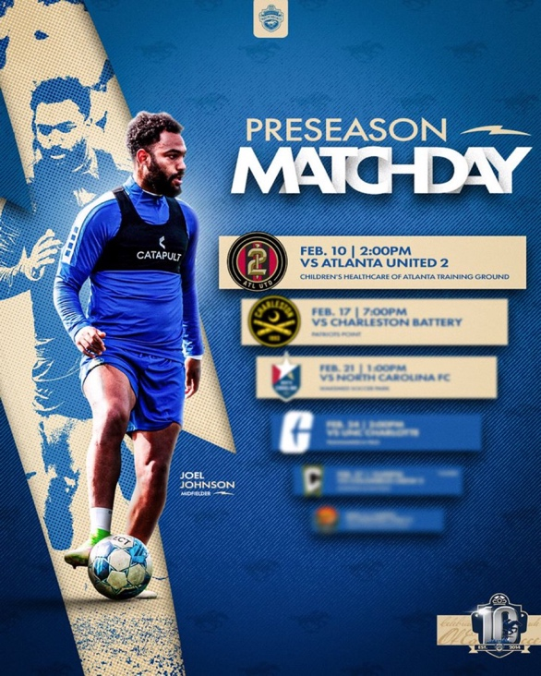

BACKYARDFOOTY’S
FOOTY CHRONICLE SERIES

CHARLOTTE INDEPENDENCE PRESEASON
WRITTEN BY KATELYN SNYDER

Footy Chronicles Preseason:

Preseason Training
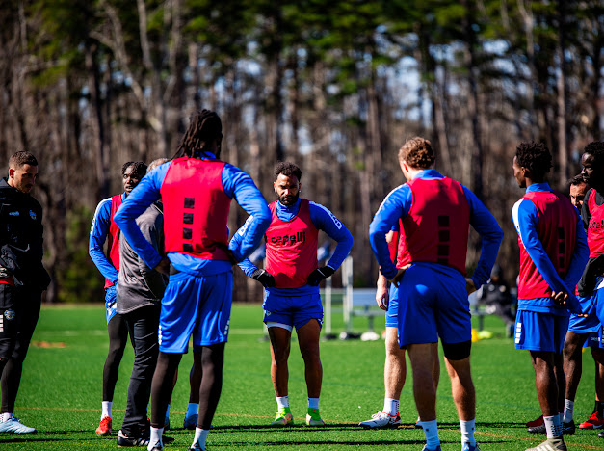
The 2024 season has finally come. Charlotte Independence has been eagerly awaiting and preparing. Now reunited, the players are back together on the pitch. This year’s team is composed of 15 players, including two goalkeepers, the head coach, three assistant coaches, and an athletic trainer. Ending their 2023 season at the top of their bracket has left a legacy for them to return to.

Preseason starts with Coach Mike Jeffries gathering the team to discuss the days ahead. This allows players to step on the field as a unit, not as individuals. They know what lies ahead and are prepared to reach their goals together. On the first day back for training, Jeffries shared highlights from the first season the club went to the USL League 1 Championship. This began the season with hopes and aspirations for the possibilities ahead.

The club provides nourishing breakfast snacks these mornings to set the boys up for success, and then it is training time. Assistant Coach Dave Carton leads them through warmups. Next, they transition straight into variations of technical passing patterns. Doing so connects the players with the ball and each other. Next up is possession. This allows them to use their touches with added defensive pressure. This is when the Coach prepares them for movement up the field. Jefferies emphasizes their quality here, spending ample time receiving the ball from the back to practice attacks on goal.

Defense is next. Formation movement as a unit is vital here. Drills are run to challenge pressing up the field. They are through scenarios and where each player should move to use the space best.
Once we were done discussing the logistics, it was time to have some fun. This is when the players can move as each feels best. Jeffries set them up to play rondos, team long ball (where the ball is kept in the air between partners), or 2v2v2v2, working to keep a team in the middle and then transition to another grid—all quick, fast, and high IQ sessions. Not only is the play enjoyable, but it also keeps them thinking.

The first week of training is intense. Each signed player spends The first two days on an immediate fitness test. This consists of twenty 100-yard runs in under 15 seconds. This year, Independence did well; only two players did not pass. Next, they focused on fitness and 8v8, which they completed by running as a team. The following two days, the team had to figure out a way to train. Their space at Matthew Sportsplex was used for a tournament. Although it wasn’t easy, they found a way to get to Rock Hill, South Carolina, for training. They each managed to find their way there, but this didn’t stop them. Each player, committed to the club, made it to training. One day was spent on grass; the next, they were able to get back on turf. It was difficult to train on different surfaces, especially when trying to bond with new teammates. Determined, the team did what they had to do to continue training. While here, they focused on a 3-team tournament, shooting on goal and, of course, followed by fitness!

After the two days, Independence returned to Matthews Sportsplex. They spent the next two days focusing on passing patterns that led to a goal, defensive shape as a back four, pressing the attacking team, and possession from goal kicks. Wednesday, they had the day off, which they were grateful for! It was a much-needed day of rest. These days, few players will work out while most will spend time in recovery. It truly depends on what each needs. The following two days were lighter functional sessions leading to the first preseason game. Time was spent working on more intricate aspects of their play, such as corner kicks, free kicks, set plays, back four shapes on crosses, and attacking plays to goal. These final sessions are vital leading up to the season.

1st Preseason Match vs Atlanta United 2 (MLS Next)

After a four-hour bus ride on February 10th, 2024, at 1 pm, the boys arrive for the first preseason match. The game started at 2 pm, giving 30 minutes to settle in and 30 minutes for starters to warm up. Carter gets them jogging, stretching, and then into square passing. Next, they get more physical in 5 v 5 + 1. They then split. Defenders hit long balls, and the attackers shot on goal. After warming up in the huddle, Jeffries emphasized staying compact as a unit, keeping the ball in possession, and pressing whenever possible. He believed this was essential if they were to leave with a win.
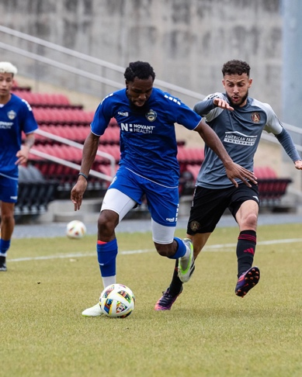
The whistle blew, and the game began. Within the first ten minutes, both teams sat back, inviting pressure, and allowing both to build possession. Independence was the first with the chance to score. Roberts was given this opportunity with a corner kick. He barely volleyed the ball over the bar. Johnson was next to make a move. He had a one-on-one with the goalkeeper, who was set up by a long ball from Speilman. It was a beautiful play, accompanied by a fingertip save from their keeper. There were few opportunities to score, with both defensive lines holding tight. As Atlanta turned on the pressure, more turnovers were made in the midfield, allowing them to regain possession of the game from the 20th-30th mark. This earned them corner kicks off Independence’s defenders, which led to their first shot over the goal.

Tied at zero, the first point came after a loss of possession from the left. Atlanta attacked down the wing. The ball was crossed at a 45-degree angle to their attacker. With one touch past defenders, they hit a goal off the far post into the net. This was their only big opportunity on goal this far, and they scored. Independence counteracted with poise and spent the last ten minutes of the half in possession. There were a few shots on goal, yet the second half ended Atlanta 1- Charlotte 0.

Although they were behind in the second half, Jefferies removed the starting 11. He put in their triallists and 2 of their signed players. Atlanta kept their lineup, with the desire to maintain their lead. Not even 5 minutes into the half, Atlanta’s defender missed a tackle on Charlotte's attacker, earning them a penalty kick. Ibarra steps up and finishes, bringing the game to a tie! For the rest of the half, both teams were low on energy, allowing minimal opportunities for a goal. With that, the match ended 1-1. Mike was satisfied with the results but walked away, knowing where work was needed. It wasn’t the hoped outcome, but the new players could compete with Atlanta’s starting lineup. Seeing what each player could manage before the official season began was valuable. It was wise of Jeffries to learn more about each of his players. This will allow the best opportunity for Charlotte Independence to continue its legacy into its 2024 season.

2nd Preseason Match vs Charleston Battery of the USL championship

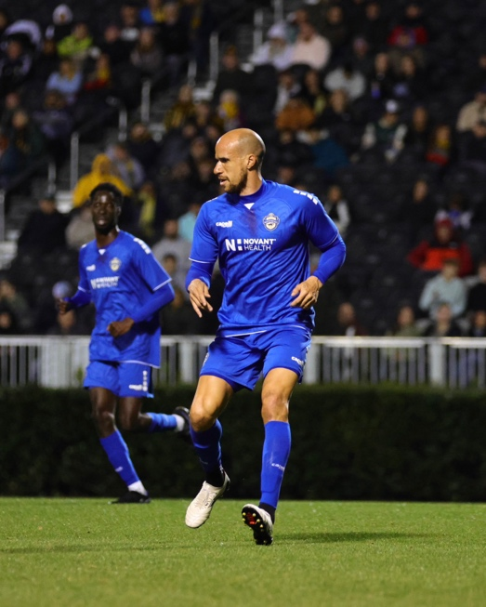
Next on the schedule, on February 17^{th,} Charlotte traveled to Charleston, SC, to play The Battery. These two teams had a long-running rivalry, and tensions were high. The game was played under the lights for their 7 pm game to set the tone even more. Preseason games are usually played during the day, but it was their fan appreciation night. This brought even more excitement to the stadium.

Both teams were itching to begin. Charlotte’s starting lineup consisted of Pack on goal, then a 4, 2, 3, 1. The defense had Roberts and Spielman as center-backs, Dimick at right-back, and a Trialist at left-back. They had Djedje, Ndyiaye, Alverez, and Johnson in the middle, and up top, Obertan and Mbuyu as strikers. Battery began the game with high pressure. This kept Independence from keeping possession, which forced them to play long. Coach Mike’s strategy was to stay in combat and press when possible. With Battery holding most possessions in the first 15 minutes, corner kicks were earned.
The defenders were able to block any of the opportunities on goal. The most threatening chance was in the 30th minute. A through ball broke through Independence's back line, bringing Pack a save. It was now Independence’s turn. Ten minutes after this save, Dimick sent a thrown ball to Johnson. With a smooth cutback, he laid the ball off to the Trialist, who could not finish. The first half ended 0-0. Again, Coach called to remove starters, taking Roberts, Oberton, Ciss, and Johnson. The score stayed the same till the 72nd minute. At this point, every starter from Independence had been removed from the game. A mix of academy players and trialists replaced them. With this switch, the game ended in Battery’s favor with the score of 2-0.

3rd Preseason Match vs NCFC of The USL Championship

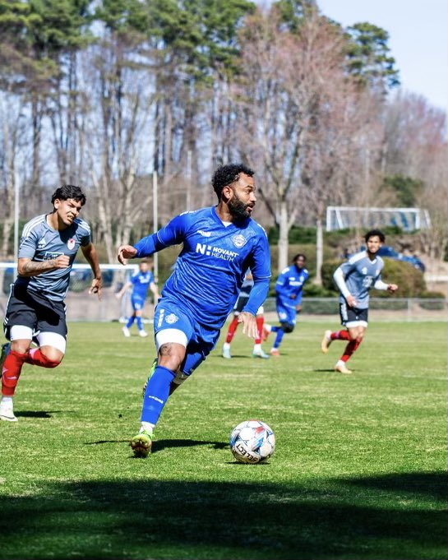
This week, Independence was off to compete with another rival. On February 21st at 2 pm, they played in Raleigh against the local NCFC. They had just come off a loss in the USL League 1 final. This game began with a different lineup shape. Coach Mike chose a 3-4-3 for the first time this preseason. He instructed the boys to stay high and press when needed. Going up against their rival, they knew what was in store for this game. He chose this setup to allow them more goal attempts and more fitness. Pack started in goal again. Roberts was right center back, Speilman was center back, and Ngah was left center back. A trialist was set as the left wing-back and Dimick as the right wing-back. The midfield was Gray, Ciss, Ibarra, and Johnson. Lastly, Mbuyu was the attacker on top.

Both teams started the game by pressing high. Things started intensely with strong tackles from each side. Early chances on goal came from the opponents. Independence’s defenders and goalkeeper shut these opportunities down. With a game only four days before, the players could feel the heaviness in their legs. Prioritizing fitness helps people prepare for the season but slows them down. With most of the possessions in NCFC’s hands in the first 20 minutes, they were first to score a goal. From a corner kick, the ball was cleared, with a second chance from a defender on the back post who tapped the ball in. Independence also had a close opportunity in the first half off a long ball. Ibarra sent a pass to Johnson, who barely missed the goal. The first half ended 1-0.

Coach Mike kept the original starting lineup, while NCFC replaced their 11 players. Again, the half began with high pressure and NCFC maintaining more possession. Independence subbed out, giving a trialist player an opportunity at striker. This moved Johnson to midfield. The switch-up brought better possession, creating more opportunities. One of these was from a corner to Roberts on the back post. He attempted to head the ball on frame but landed with the keeper. After a few more substitutions, NCFC earned two penalties and finished both. With a 3-0 score, the game ended. In 4 days, the team played two championship-level teams. They did not win but valued the lessons learned through this rare experience.
4th Preseason Match vs Columbus Crew (MLS Next)

With a much-needed whole week, Independence trained for their first upcoming local game scheduled for February 27th. There was a noticeably different energy in this match. The boys came with more confidence. Coach Mike’s pregame emphasis was again to press high. He encouraged them to try and create turnovers. Their opponents were known for keeping possession in risky positions. He felt this could be used to their advantage. On top of the boys feeling more at home on their field, they also returned to their original formation of 4-2-3-1. They had Dimick, Roberts, Speilman, and Ngah in the back. The midfielders were Ciss Ndiaye, Johnson, and Mbuyu. On top of this, the attackers were Obertan and a trialist.
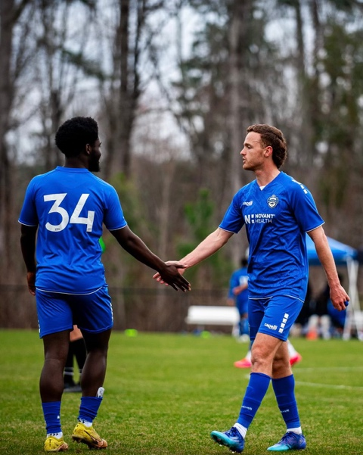
The game began with high pressure from both ends, giving mutual early opportunities. Independence’s closest shot came from Obertan in the first 10 minutes. With a combination play between himself and Mbuyu, he was set up for a cross to the near post. The Crew’s keeper grabbed the ball, ending the play. The next opportunity came from the right side, where Dimick and Johnson played off each other. Dimick then crossed the ball to the trialists, who slotted it home for Independence’s first home goal of the season. Columbus responded by overloading the middle and gaining a turnover on the left side. The ball was crossed in the box to their midfielder, who finished for a goal. Independence did not shut down. They continued their heavy pressure, resulting in more opportunities for goals from attackers.

A majority of the second-half lineup stayed the same. Only three changes were made: Trialist was traded for Trialist, Gray for Ciss, and Luis for Bachir. Even with the changes, the pressure continued. Ngah and Trialist worked together through Crew’s players. It led them forward, giving the Trialist a header finished on goal and going to the back post. Independence now had the lead. The Crew counteracted with intensity, keeping possession high from that point. Independence wanted to secure their lead and continued to counter. An academy player heading to goal was tackled from behind in the box. A trialist was set up for the penalty kick, and he finished, giving Independence more security. Coach Mike took the rest of his subs off in the last ten minutes. With that, Independence had their first victory!
5th Preseason Match vs Carolina Core (MLS Next)

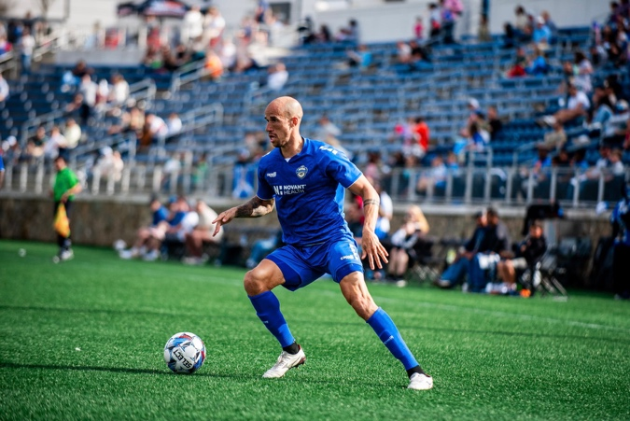
Independence is back home at the American Memorial Stadium for their March 2nd match. They hosted the new Carolina Core MLS Next team from High Point, NC. Tonight was fan night, which allowed them to watch for the first time this season for free. Post-game, the players would spend time with them signing autographs. The team arrived an hour and a half early for their first home game. Coach Mike emphasized staying compact and pressing when able. He instructed the boys to focus on keeping the ball in possession. Then, when allowed, make direct moves. As a new local rival, it was vital for the boys to send a message.

They stayed in their 4-2-3-1 formation in this match, where they were most comfortable. Pack started in goal with Dimick, Roberts, Spielman, and Ngah before him. Luiz, Ndiaye, Johnson, Mbuyu, and Belmar were in the center, and Obertan was the attacker. Pressure was high for both teams to start. Independence’s mistakes allowed Core to find early opportunities at goal. Pack and the defenders held, allowing nothing to slip through. The most significant chance of the game was movement between Obertan and Mbuyu. With a give-and-go up the right wing, Mbuyu sent a low cross to the near post, where Belmar finessed to the corner. The keeper saved this shot with his foot, ending the first half 0-0.

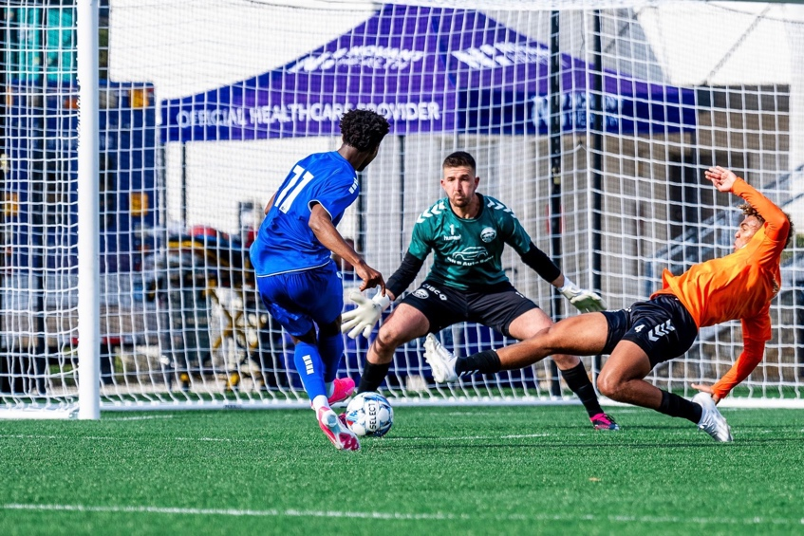
The same energy bled into the second half. Core kept most of the possession without many opportunities on goal. Independence’s backline was holding firm. It wasn’t until around the 70th minute that a turnover was made on the left wing. Opponents played a through ball into the box to an incoming attacker, creating a foul from the defense. They earned a penalty kick and scored. With little time left, Coach Mike switched the formation to 3-4-3, substituting five younger, fresh legs. Sorensen, Grey, and Akyeampong, along with 2 Academy players, were put in. This was a good call by the Coach, resulting in more applied pressure. Independence gained most of the possession for the last 15 minutes of the game. Anton crossed the ball, giving Mbyu rebound shots on goal. A young academy player was finally able to finish the shot off a rebound finally. Mbuyu created another opportunity by applying pressure on his half. He stole the ball from center back and took it solo for a goal, slotting it in the near corner. With that, the game was won! Independence ended their preseason's first and last home game with a win. There is greater joy spent with fans when a win is in the books. We are excited to see what the 2024 will bring. Stay tuned for player recaps from Independence’s first game.

