Open Cup vs EV (March 21st)
Travel Day
On a windy Wednesday night, Independence flew to Langhorne, PA. Most players from the south were not used to the temperature and struggled to stay warm. Here, they would compete in their first One Cup match. Their competition was a German amateur team, VE. This team was filled with former collegiate and pro players. Before heading to bed, the boys met for dinner to conclude their travel day.
Game Day
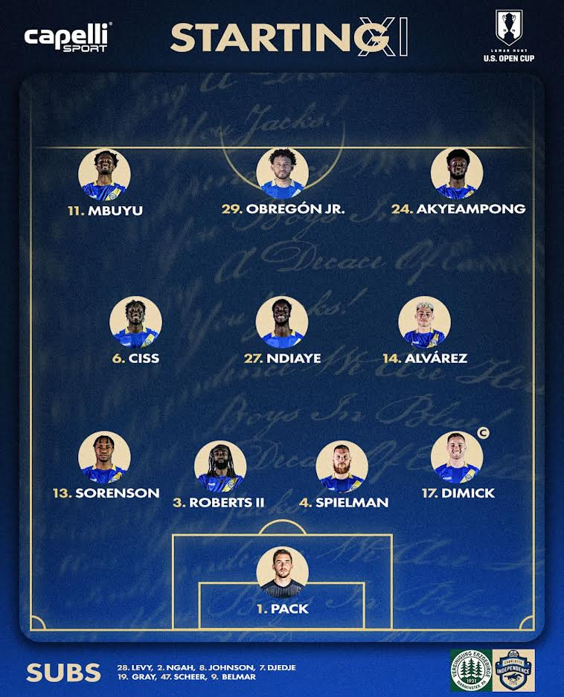
The following day, each player fed themselves for breakfast. They were then gathered at 10 am to discuss pregame preparations. They watched films from previous games and discussed the tactics of the other team and their game plan against them. After this, there was more free time to prepare as needed. The team reunited 4 hours later to have a pregame meal at 3:30 pm. With a few more hours of downtime, the boys were ready to head to the stadium.
Arriving at Cairn University was the middle of nowhere for these Charlotte boys. High energy still met the boys, who were far from civilization. Fans emerged from the woodwork to bring an atmosphere that matched the game's thrill. Captain Dimick felt today would be a mentality test for the team. On paper, he knew their quality; the mindset just had to match. He encouraged the boys to work off the ball and defensively, then show their value when in possession.
Coach Mikes emphasized to the boys that this Open Cup first round came with awaited excitement. The players were enthusiastic, and the crowd brought that same energy. He wanted them to match the intensity and come out strong. They started with a 4-3-3 lineup. Pack was in goal with Dimick, Roberts, Speilman, and Sorenson in the back. Ciss, Ndiaye, and Alvarez were in the center, and Mbuyu Obregon and a new sign, Akyeampong, were up top. This was the first time most of these players had played together; it did not disappoint.
Game Time
Ref blows the whistle, and the high intensity from VE commences. Within the first 5 minutes, they hit the post on a corner kick, and the crowd went wild. Everyone knew there was a good game ahead of them. After 10-15 minutes, Independence had more of a flow between their plays and gained more possession. They were moving the ball well together. About 75% of the possession was at their feet in the first half. VE sat back and stayed compact. Neither team had many opportunities on goal. There were a few corner-kick opportunities, but their attempts were shut down. Independence held dominance for the rest of the half, which ended at 0-0.
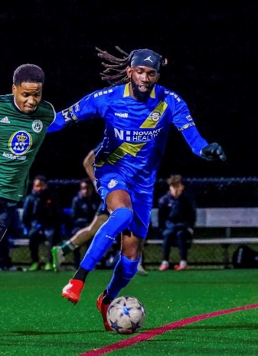
The same vigor continued into the second half. They managed to hold the bulk of possession. VE was berated with shot after shot! Although the boys overpowered the other team, the score stayed the same. Around the 70th minute, Coach Mike made changes. He puts Joelle Johnson in for Belmar. Also, a new signing and Ryan as well to center mid. This entirely transformed the game. There was more quality play on the field, and players had more time on the ball. This led to their first goal! It began with an interchange between Johnson, Ciss, Oberton, and Alverez. Ciss finished the play with a left-footed shot from the top of the left-side 18-yard box. It hit the right corner. Independence now took the lead, 1-0. They continued to push strong and keep control of their possessions. Within the last ten minutes, Omar, Johnson, Alverez, and Oberton created a cross from Ciss to the back post, where Belmar quickly headed in, bringing the game to a 2-0 win!
Post Game
The players felt better about their performance than their home opener against Knoxville. The team from this match seemed miles ahead of their last game. Independence had an injury inventory of Shalom Duty, Gabriel Oberton, and Miguel Ibarra. Even with the few players missing in action, this was the best the boys have played all season. Players were moving well, showing for the ball, and it seemed everyone was finally on the same page. The quality Dimick had mentioned was seen. He felt their professionalism showed in this game. With the 2-0 win, he was proud, as a defender, for the shutout. Confidence was built, and momentum was made for this season. The boys passed their mentality test and showed their true team colors. They returned to the hotel for the night and left early the following day to return home. This was the boost needed as they prepared for their second round against South Carolina United.

